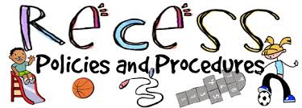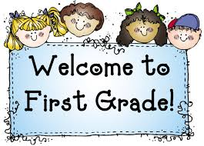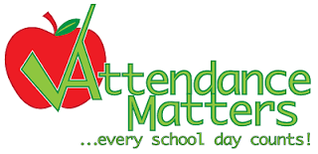 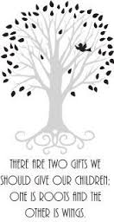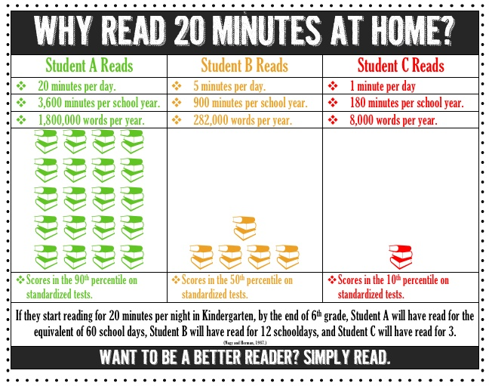

**Box Tops &**

**Scholastic Book Club**

* We DO collect Box Tops to purchase new library books!
* Scholastic books will be available to purchase monthly if you choose to order. Our on-line class code is DXGJ9.

You are welcome to eat lunch with your child at 11:15 and join them for recess afterwards! Just call our secretary by 8:00 to reserve a tray and pay in the office when you arrive.

**Visitor’s Welcome!**

In our efforts to remain a healthy school and refrain from allergic reactions, food treats are not allowed to be brought in for birthdays. You are welcome to celebrate your child’s birthday by sending in other types of items such as pencils, markers, erasers, bubbles, etc.

**Contact Information**

**Mrs. Heather Tretter**

**e-mail:** [htretter@nspencer.k12.in.us](mailto:htretter@nspencer.k12.in.us)

**school phone #:** 812-937-2400 Ex: 6

**home phone #:** 812-367-1978

**text #:** 812-630-1118

**website:** tretter.weebly.com

**Daily Schedule**

7:50-8:00 Math Fact Fluency

8:00-8:30 Reading Intervention

8:30-9:30 Guided Reading

9:30-9:45 Recess

9:45-10:30 Writing

10:30-11:15 Shared Reading / Read Aloud

11:15-12:15 Lunch / Recess

12:15-1:00 Special Area Class

1:00-2:00 Guided Math

2:00-2:30 Calendar & Math Intervention

2:30-3:00 Word Work/

Science / Social Studies

**Birthdays**

In first grade most of our work is oral and hands-on, which cannot be made up after an absence. Please try to schedule appointments before and after school or (if no other option) in the afternoon. Please call the office or email me to notify us of an absence. Missed homework will be sent home upon your child’s return unless other arrangements are made.

*If the weather is suitable we’ll have outdoor recess. Please send your child in appropriate clothes during winter months (including hat, glove, and coat labeled with your child’s name.)

*In addition to a 15 minute morning recess and 30 minute lunch recess, students have several brain breaks (brief periods of physical activity) throughout the day to energize and stimulate brains, improve concentration and relieve stress.

\***P.E.:** Please wear tennis shoes and comfortable running clothes on P.E. days.

\***Library:** Please return library books weekly. Other books cannot be checked out if previous week’s books are not returned.

Monday: P.E.

Tuesday: Art

Wednesday: Technology

Thursday: Library

Friday: Music

Inspire! Learn! Grow!

## **SSSpecial Area Classes**

### Donec consequat congue libero.

105 Dunn Street  
Dale, IN 47532  
dtec.nspencer.k12.in.us

David Turnham Educational Center

Lorem  
Ipsum Dolor

Students will receive a progress report every nine weeks. The following marks will be used to evaluate student progress…

4 - Consistently demonstrates exceptional

grade level knowledge and skills

3 - Consistently demonstrates grade level

knowledge and skills

2 – Inconsistently demonstrates grade level

knowledge and skills

1 - Demonstrates a lack of grade level

knowledge and skills

On classroom assessments, a “Target Score” (grade level expectation), will be circled in the upper right hand corner (___/___). Papers with no target scores are practice.

You will also receive monthly DIBELS reports which monitor your child’s reading growth and quarterly benchmark assessment scores.

Weekly newsletters, class website, e-mails, and phone calls will also keep you informed.

* **STAR SCHOLARS -** Awarded quarterly to students who are consistently demonstrating or exceeding grade level knowledge and skills
* **STARS** - Pizza with principal and dog tag for demonstrating strong character traits or improvement
* **ACADEMIC AWARDS** – Quarterly grade level math, reading, writing, and personal best awards
* **PERFECT ATTENDANCE all year –** dog tag and chance for bike drawing

**Homework Expectations**

*Each evening, Monday-Thursday, students will have 20-30 minutes of homework.

*Occasionally you will find math or reading homework that your child was unable to complete in class in the “Bring Back to School” section of your child’s Homework Folder. If work is completed in class your child may not have a handout.

*Please open their homework folder each evening to review their papers and help your child clean out the papers in the “Leave At Home” section.

*Your child should return his/her reading book and homework folder every day to school.

*Children who don’t complete homework will finish it during a portion of their recess time.

*If you have a busy evening or don’t understand an assignment, please e-mail me or send a note and I will excuse the student (if sent occasionally).

**Homework Procedures**

**Reading:**

* Read and discuss assigned story *(or book of choice if assigned story becomes too easy)*
* Fluency in center of homework folder *(will build from sight word lists, to fry phrases, to reading passage with comprehension questions)*
* Word ring or word list (*2-3 nights a week)*

**Math:**

* Handout *(if not completed in class)*
* Practice math facts (*use the packet insert in the homework folder. Keep it in the sleeve and use a dry erase marker to practice over and over. (Or use apps, websites, or flashcards – see my website for ideas!)*

**Word Block:**

* Practice spelling the weekly sight words and phonics pattern words. Test on Fridays.

**\*If your child has no other homework, PLEASE e encourage him/her to read for 20 minutes!**

**Student Recognition**

**Evaluation of Progress**

~Together may we give our children the roots to grow and the wings to fly.~

Homework Procedures and Expectations